Name: Sujit Kumar Datta

ID: 22201946

Section: 19

Course Code: CSE221

**Lab Assignment 07**

**Task 1**

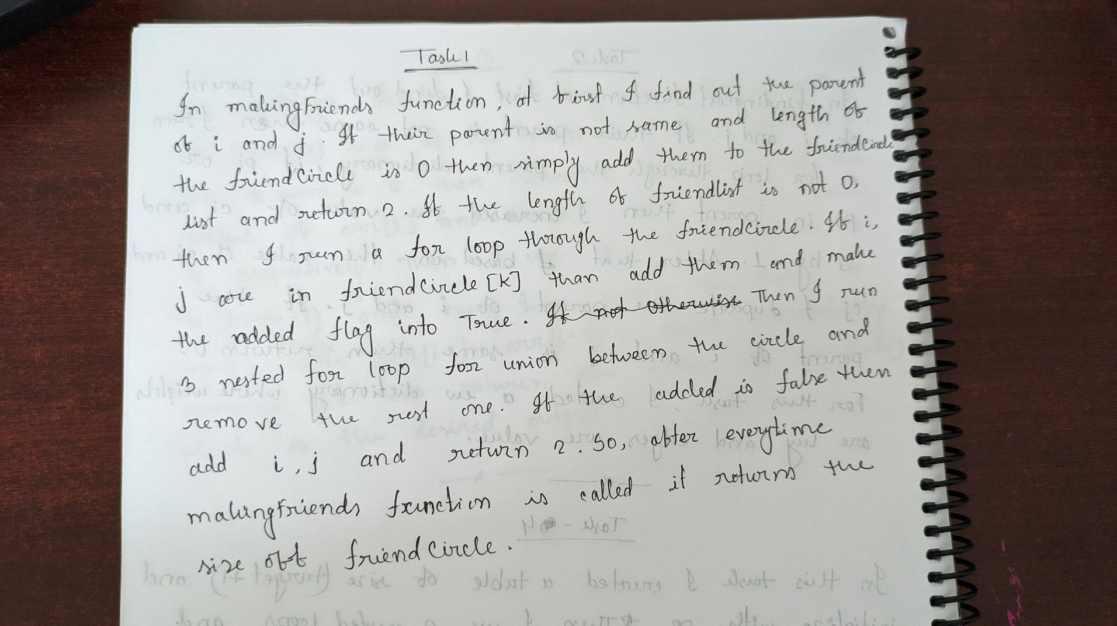

**Task 2**

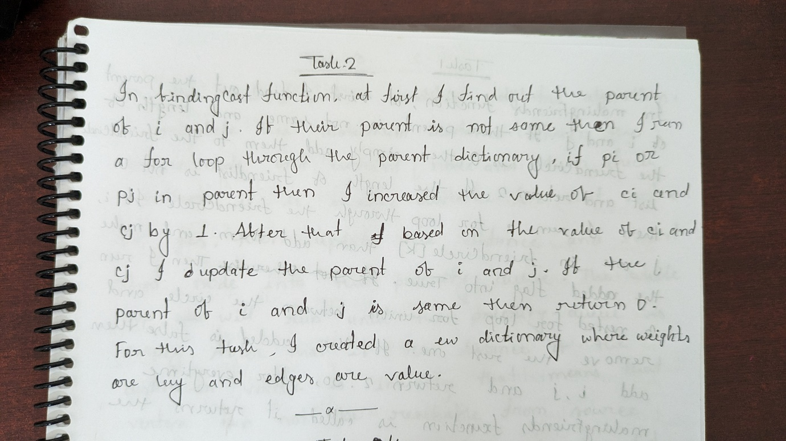

**Task 3**

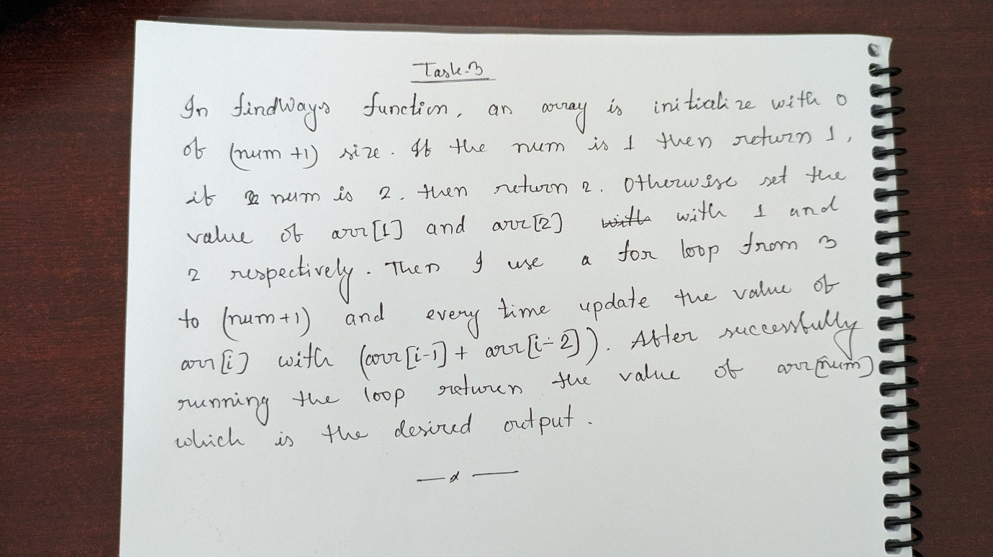

**Task 4**

